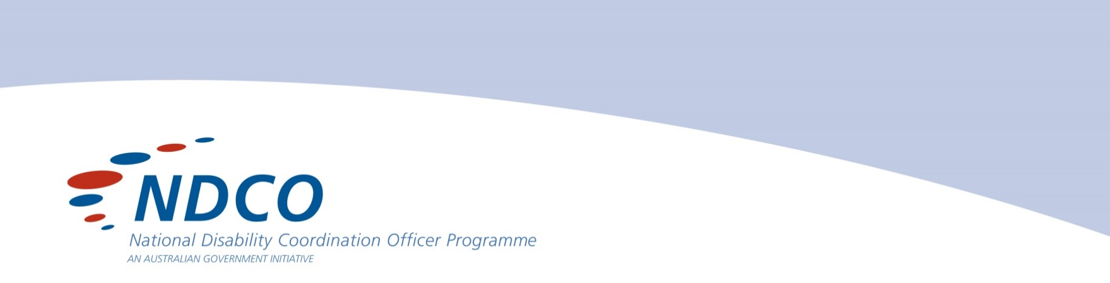

Peak Bodies
& Services

Refugee Council of Australia
This national member based organisation represents refugees and other organisations who provide assistance to them. The website provides a great deal of relevant information including fact sheets, resources, publications and service directories.
www.refugeecouncil.org.au/

Victorian Multicultural Commission (VMC)
VMC provides advice to the state government on multicultural affairs and supports partnerships to enhance services for diverse communities. Their website provides an extensive range of information about migration, multicultural issues, a community notice board and an interfaith calendar of events.
www.multicultural.vic.gov.au/

Centre for Multicultural Youth (CMY)
CMY is a Victorian not-for-profit organisation supporting young people from migrant and refugee backgrounds to build better lives in Australia.
www.cmy.net.au/

AMES
AMES has worked for over 60 years to help settle new migrants and refugees into our community. They partner with the community, government and business to develop good connections for newly arrived people. They have a vast amount of valuable information on their website.
www.ames.net.au/

Migrant Resource Centres
To find your local migrant resource centre in metropolitan and regional Victoria please go to the following link.
www.dhs.vic.gov.au › ... › Management toolkit › Diversity

National Ethnic Disability Alliance (NEDA)
NEDA is a national peak organisation representing the rights and interests of people from non-English speaking backgrounds (NESB) with disability, their families and carers throughout Australia. The majority of councillors are people from NESB with disability, their families and carers.
www.neda.org.au/

National Aboriginal Community Controlled Health Organisation (NACCHO)
NACCHO is a national peak body and has a wealth of information on Aboriginal Health and Wellbeing issues. Also please see Victorian Aboriginal Community Controlled Health Organisation Inc. (VACCHO).
www.naccho.org.au/

